Mike Yoon

CS443

Professor Hadaegh

Assignment 1

1. **a.**

Product (ProductID, ProductDescription)

Receipt (ReceiptNumber, SalesDate)

Item (ItemNum, ItemDescription)

Sold (ProductID*, ReceiptNumber*, QuantitySold)

Used (ProductID*, ItemNum*, QuantityUsed)

**b.**

The tables are already in third normal form because they do have any derived or transitive dependencies.

**c.**

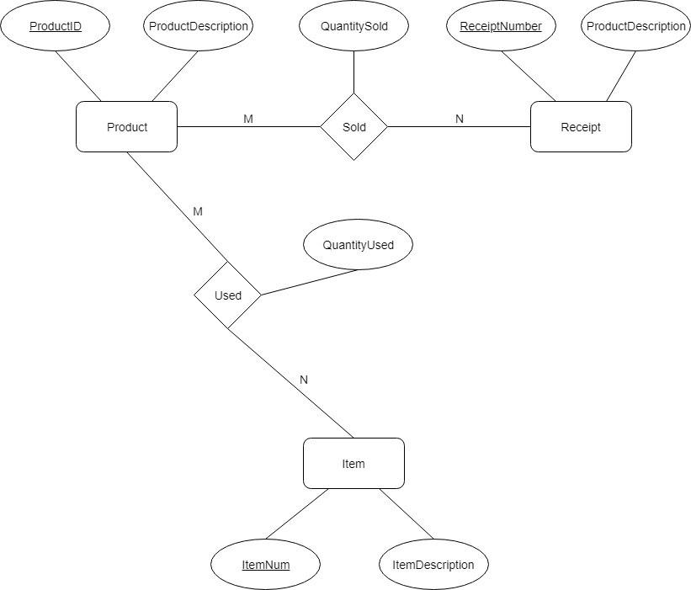

**d.**

CREATE TABLE Product (

ProductID NUMBER,

ProductDescription VARCHAR2(200),

CONSTRAINT Product_PK PRIMARY KEY(ProductID)

);

CREATE TABLE Receipt (

ReceiptNumber NUMBER,

SalesDate DATE,

CONSTRAINT Receipt_PK PRIMARY KEY(ReceiptNumber)

);

CREATE TABLE Item (

ItemNum NUMBER,

ItemDescription VARCHAR2(200),

CONSTRAINT Item_PK PRIMARY KEY(ItemNum)

);

CREATE TABLE Sold (

ProductID NUMBER,

ReceiptNumber NUMBER,

QuantitySold NUMBER,

CONSTRAINT Sold_PK PRIMARY KEY(ProductID, ReceiptNumber),

CONSTRAINT Sold_FK1 FOREIGN KEY(ProductID) REFERENCES

Product(ProductID),

CONSTRAINT Sold_FK2 FOREIGN KEY(ReceiptNumber) REFERENCES

Receipt(ReceiptNumber),

CONSTRAINT QuantitySold_CK CHECK(QuantitySold >= 0)

);

CREATE TABLE Used (

ProductID NUMBER,

ItemNum NUMBER,

QuantityUsed NUMBER,

CONSTRAINT Used_PK PRIMARY KEY(ProductID, ItemNum),

CONSTRAINT Used_FK1 FOREIGN KEY(ProductID) REFERENCES

Product(ProductID),

CONSTRAINT Used_FK2 FOREIGN KEY(ItemNum) REFERENCES

Item(ItemNum),

CONSTRAINT QuantityUsed_CK CHECK(QuantityUsed >= 0)

);

1. **a.**

Physician (PhysID, PhysName, PhysDept, DeptSupervisorId, TreatDesc, TreatCost, TreatId)

Patient (PatientID, PatientName, PatientAddress, HospitalStayDays, AdmitDate, RoomNo, RoomRate, RoomPhone, AmountOwing, PhysID*)

**b.**

Physician (PhysID, PhysName, PhysDept, TreatId*)

Department (PhysDept, DeptSupervisorId*)

Treatment (TreatId, TreatDesc, TreatCost)

Patient (PatientID, PatientName, PatientAddress, HospitalStayDays, AdmitDate, RoomNo*, PhysID*)

Room (RoomNo, RoomRate, RoomPhone)

The table from part a. had transitive and derived dependencies in which can be broken up into separate different tables (Department, Physician, Patient, Room and Treatment). All the tables are now in third normal form.

**c.**

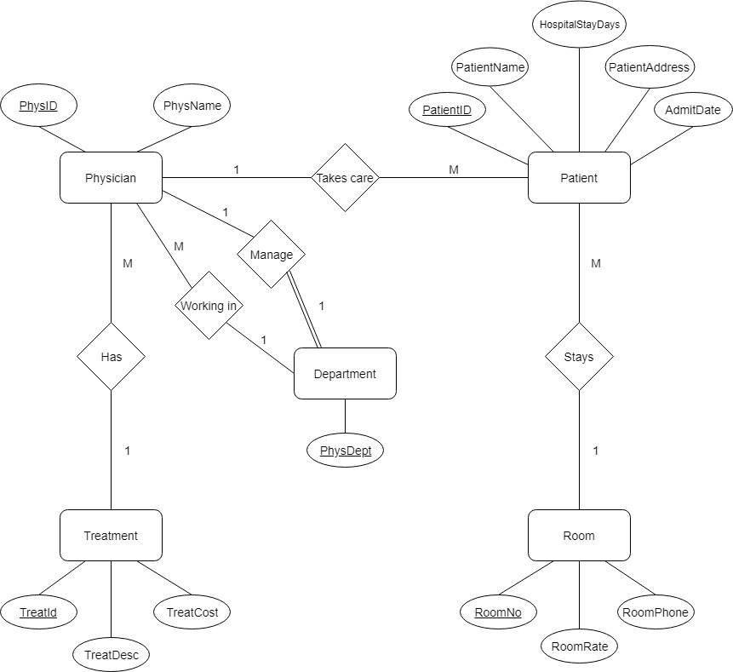

**d.**

CREATE TABLE Room (

RoomNo NUMBER,

RoomPhone VARCHAR(8),

RoomRate NUMBER(10, 2),

CONSTRAINT Room_PK PRIMARY KEY(RoomNo),

CONSTRAINT RoomRate_CK CHECK(RoomRate >= 30.00 AND

RoomRate <= 100.00),

CONSTRAINT RoomNo_CK CHECK(RoomNo >= 100 AND

RoomNo <= 900)

);

CREATE TABLE Department (

PhysDept NUMBER,

DeptSupervisorId NUMBER,

CONSTRAINT Department_PK PRIMARY KEY(PhysDept)

);

CREATE TABLE Treatment (

TreatId NUMBER,

TreatDesc VARCHAR2(200),

TreatCost NUMBER(10, 2),

CONSTRAINT Treatment_PK PRIMARY KEY(TreatId),

CONSTRAINT TreatCost_CK CHECK(TreatCost >= 50.00)

);

CREATE TABLE Physician (

PhysID NUMBER,

PhysName VARCHAR2(50) ,

CONSTRAINT PhysName_Null NOT NULL,

DeptSupervisorId NUMBER,

PhysDept NUMBER.

TreatId NUMBER,

CONSTRAINT Physician_PK PRIMARY KEY(PhysID),

CONSTRAINT Physician_FK1 FOREIGN KEY(PhysDept) REFERENCES

Department(PhysDept),

CONSTRAINT Physician_FK2 FOREIGN KEY(TreatId) REFERENCES

Treatment(TreatId)

);

CREATE TABLE Patient (

PatientID NUMBER,

PhysName VARCHAR2(50),

CONSTRAINT PhysName_Null NOT NULL,

PatientAddress VARCHAR2(200),

CONSTRAINT PatientAddress_Null NOT NULL,

HospitalStayDays NUMBER,

AdminDate DATE,

RoomNo NUMBER,

PhysID NUMBER,

CONSTRAINT Patient_PK PRIMARY KEY(PatientID),

CONSTRAINT Patient_FK1 FOREIGN KEY(RoomNo) REFERENCES

Room(RoomNo),

CONSTRAINT Patient_FK2 FOREIGN KEY(PhysID) REFERENCES

Physician(PhysID)

CONSTRAINT HospitalStayDays_CK CHECK(HospitalStayDays >= 0)

);

ALTER TABLE DEPARTMENT

ADD CONSTRAINT Department_FK1 FOREIGN KEY(DepartSupervisorId) REFERENCES

Physician(PhysID);

1. A (A1, A2)

B (B1, B2, A1, C1)

C (C1, C2)

D (D1, D5, D2, D3, D4)

E (E1, E2, (D1, D5)*, AttOfR4)

F (F1, F2, F3, F4, (D1, D5, E1)*, AttOfR5)

R3 (AttOfR3, C1*, (D1, D5)*)

1. BANK (Code, Name, Addr)

BANK-BRANCH (BranchNo, Code*, Addr)

LOAN (LoanNo, Amount, Type, Code*, BranchNo*)

ACCOUNT (AcctNo, Balance, Type, Code*, BranchNo*)

CUSTOMER (SSN, Name, Phone, Addr)

A-C (AcctNo*, SSN*)

L-C (LoanNo*, SSN*)

